# Worksheet 3a Functions

1. **Create a series of functions for a robot to do your household chores**

e.g. Washing up, vacuuming, making the bed

Add some function calls at the end of the program so that the robot will do them

Your answer should look something like this:

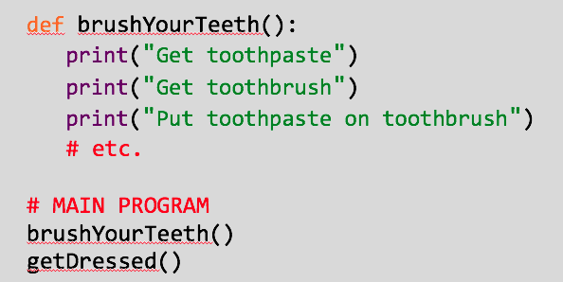

1. **Tic - Tac - Toe**

Use the following function calls to put together a complete game of Tic Tac Toe.

Rewrite them and repeat them (on paper) in an order that would allow you to play the game. You can do this as a flowchart instead if you prefer.

Test the game by playing against someone else (you play as the player, they play as the computer). Neither one is allowed to do anything that isn’t in the program you’ve designed.

drawGrid()  
playerChooses()  
checkIfSomeoneWon()  
computerChooses()  
checkIfSomeoneWon()

1. **Tic - Tac - Toe**

Download the Tic Tac Toe program (L3 WS3a Ex2 tic_tac_toe.py).

The subroutines are already completed for you, all you need to do is uncomment the calls at the bottom of the program. You can copy each one as many times as you need to.

Test the program thoroughly – make sure it works if you win, lose or draw (it might take a few goes to lose successfully!)­.